**DAILY ONLINE ACTIVITIES SUMMARY**

|  |  |  |  |  |  |  |  |  |
| --- | --- | --- | --- | --- | --- | --- | --- | --- |
| **Date:** | **16/06/2020** | | | | | **Name:** | **AKASH S** | |
| **Sem & Sec** | **4TH&A** | | | | | **USN:** | **4AL18CS004** | |
| **Online Test Summary** | | | | | | | | |
| **Subject** | | **COMPLEX ANALYSIS,PROBABILITY AND STASTICAL METHOD** | | | | | | |
| **Max. Marks** | | **30** | | **Score** | | | **26** | |
| **Certification Course Summary** | | | | | | | | |
| **Course** | **INTRODUCTION TO NEURAL NETWORK AND DEEP LEARNING** | | | | | | | |
| **Certificate Provider** | | | **GREAT LEARNING** | | **Duration** | | | **9.5 HOURS** |
| **Coding Challenges** | | | | | | | | |
| **Problem Statement 1: Write a C Program to implement the Binary Reversal.** | | | | | | | | |
| **Status: executed** | | | | | | | | |
| **Uploaded the report in Github** | | | | | **YES** | | | |
| **If yes Repository name** | | | | | <https://github.com/akashacharya786/lockdown-c-coding>  **https://github.com/akashacharya786/lockdown-java-coding** | | | |
| **Uploaded the report in slack** | | | | | **YES** | | | |

**Online Test Summary:** 18MAT41 online test was scheduled from 3 pm to 3:40pm. The portion for the IA was module 1. The question were MCQ type There were 15 question each question carries 2 mark respectively duration is 40 minutes .The score I received was 26/30.

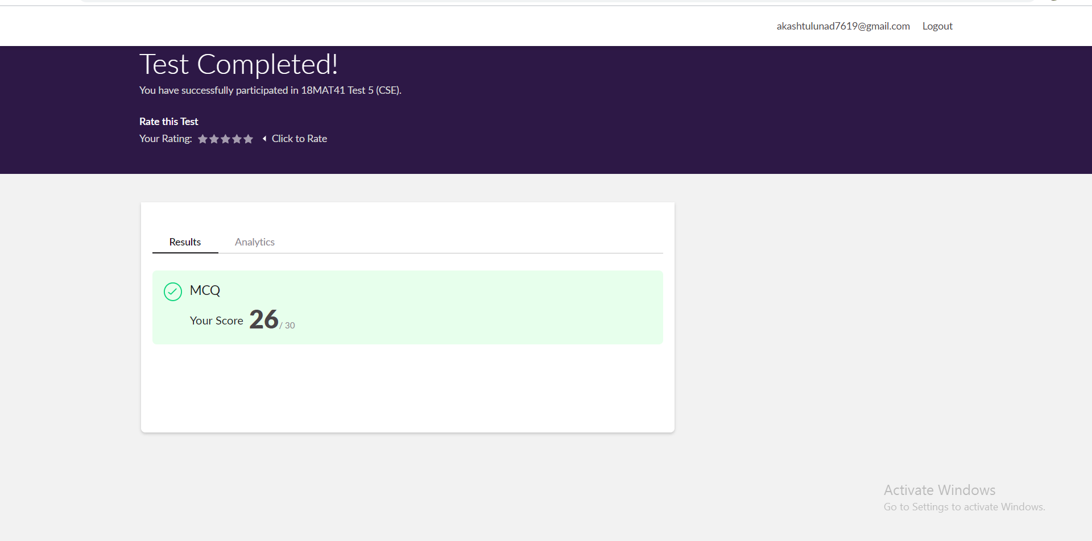

**Online Certification course:**

Name of the course : Introduction to neural network and deep learning

Duration: 9.5 hours

Certificate provider: great learning

Snap shot:

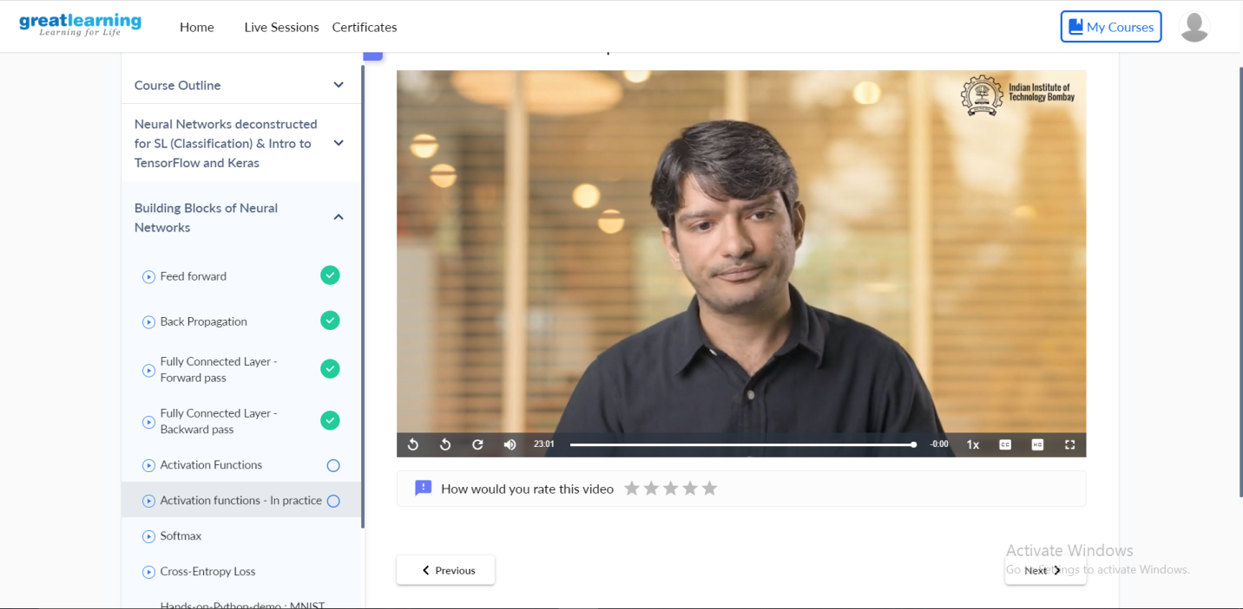

In todays video I learnt about

* Fully conducted layer –forward pass
* Backward pass
* Activation functions
* Activation functions –In practice

Online Coding summary:

1.  **Write a C Program to implement the Binary Reversal.**

